Lab Report: Network design and load shading solution.

Course: CSE-4512 [Computer Networks Lab]
Name: Rafat Abdullah
ID: 220041102
Date: November 24,2025
Section: 1B

Problem Statement:
We have to create a network that can with stand and fault in the line and send data. The 2 primary constrains:
- Custom addressing: the network use a special IP address template. (For me the template is 192.2.x.x)
- Reliability: the network infrastructure must be resilient to power outage. If a router fails the other must be able to communicate without any problem.
- Full reachability among all the PCs

Proposed Solution:
To address the load shading we can do either Mesh topology or Ring topology. But Ring topology is more convenient because
- It is easy to configure.
- Less costly.
- Modification is easier.

Screenshot of the final Network topology:
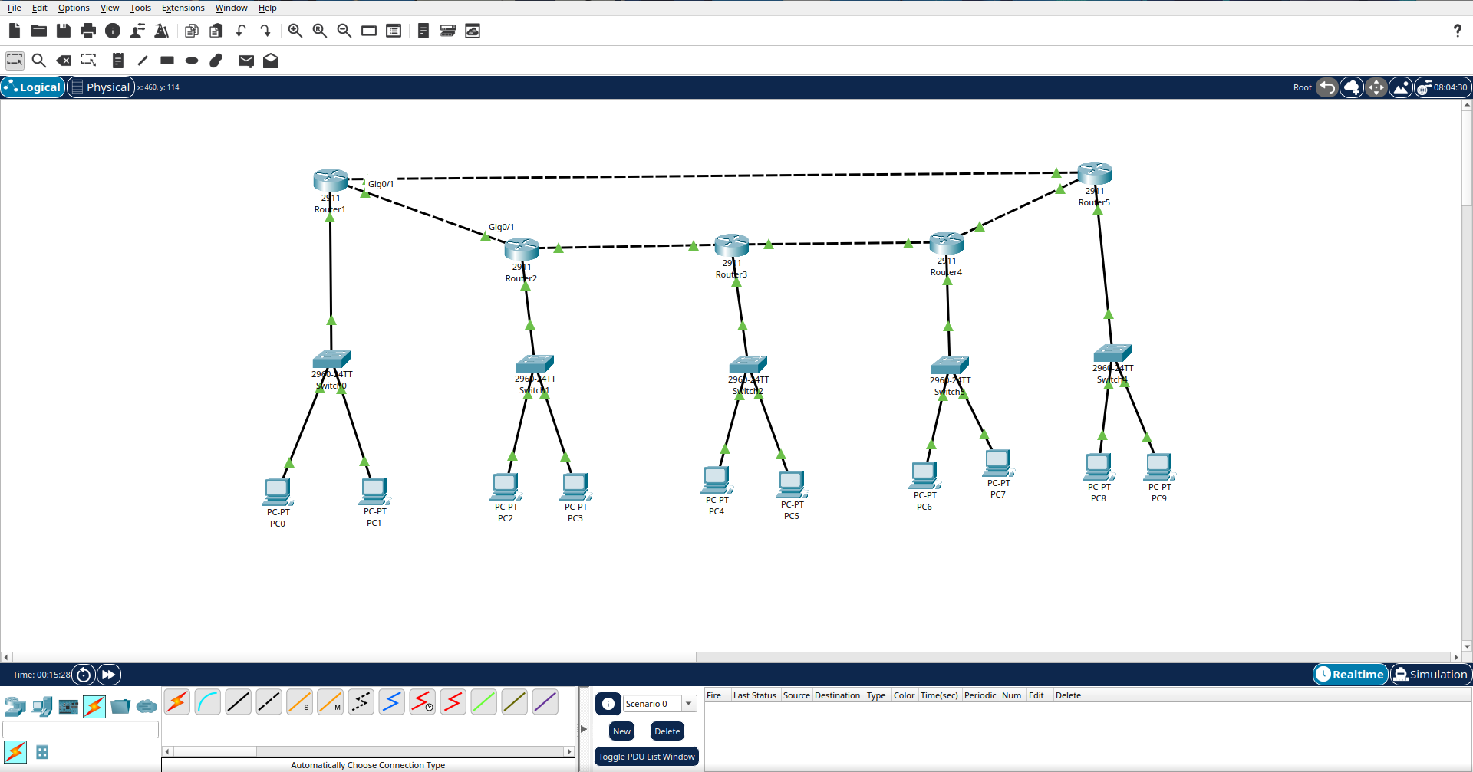

Short procedure:
- Physical Topology setup:
- Place 5 routers 2911 in a ring arrangement.
- Place 5 switches 2960 and 10 PCs(2 in each lab)
- Connect the pc and switches with auto cable detection function do same for the router to router and switch to router.
- IP address planning:
- Based on student id the second octet was taken 02.
- Unique subnet was given to each pcs and routers.
- Interface configuration:
- Configured the GigabitEthernet interfaces on all 5 routers. With their respective IP address.
- Enabled all ports with no shutdown command
- PC configuration:
- Manually assigned all 10PCs’ IP addresses.
- Configures the default gateway on every pc to it’s local router’s LAN interface address
- Implementing dynamic routing(OSPF):
- To solve the the “Load shedding” requirement, the OSPF protocol was configured on all routers to allow automatic path selection.

Justification:
In ring topology, every router is connected to exactly 2 other routers, forming a closed loop. This structure provides a redundancy in data flow. If the direct link between the lab 1 and lab 2 goes cut due to power outage the flow uses the following path
Lab1 -> lab5 -> lab4 -> lab3 -> lab2

Logical design:
- Total labs: 5
- Total PCs: 10 (2 per lab)
- Routing protocol: shortest path or usable path. If shortest path not available only then use the other usable path

IP addressing scheme:
192.2.0.0 was used for all subnets.

Device addressing table:
Location | Router (Gateway) | Subnet Network | PC 1 IP | PC 2 IP
Lab 1 | 192.2.1.1 | 192.2.1.0/24 | 192.2.1.2 | 192.2.1.3
Lab 2 | 192.2.2.1 | 192.2.2.0/24 | 192.2.2.2 | 192.2.2.3
Lab 3 | 192.2.3.1 | 192.2.3.0/24 | 192.2.3.2 | 192.2.3.3
Lab 4 | 192.2.4.1 | 192.2.4.0/24 | 192.2.4.2 | 192.2.4.3
Lab 5 | 192.2.5.1 | 192.2.5.0/24 | 192.2.5.2 | 192.2.5.3

WAN Links:
- R1-R2: 192.2.12.0/24
- R2-R3: 192.2.23.0/24
- R3-R4: 192.2.34.0/24
- R4-R5: 192.2.45.0/24
- R5-R1: 192.2.51.0/24

Implementation Details:

Hardware Used:
- Routers: 5x cisco 2911 routers
- Switches: 5x cisco 2960 switches
- End devices: 10x generic desktop pcs
- Cabling: copper straigth-through and gigabit ethernet

Configuration Strategy:
The OSPF command used on every router was:
```bash
router ospf 1
network 192.2.0.0 0.0.255.255 area 0
```

Simulation Result and verification:

Connectivity verification:
The network was first tested under normal conditions. A ping packet was sent from pc in one lab to another pc in another lab.
- Result: Package sending was 100% successful
- Observation-1: The packages tried to take the shortest path.
- Observation-2: When one connection was savered the packet send was still successful between 2 nodes.

Fault Tolerance Test:
To check fault tolerance a cable between 2 routers in the path was disconnected. Still the re was a valid connection.

Challenges Faced During the Lab:
- Gateway Configuration Error: Initially, pings were failing with "Request Timed Out" even though the routers were green. I realized I had configured the Router IPs correctly but failed to set the Default Gateway on the PCs. Once I added the Gateway IP (e.g., 192.2.1.1) to the PC settings, the issue was resolved.

- Topology Selection: Deciding between a Mesh and a Ring topology was challenging. I chose the Ring topology because it offers sufficient redundancy for the "load shedding" scenario while using fewer cables and ports than a full Mesh.

- OSPF Convergence: Understanding that there is a slight delay (convergence time) when a cable is cut. During the test, I initially thought the backup failed because the first few pings timed out, but I learned that OSPF needs a few seconds to recalculate the new route.

Conclusion:
The project met all design requirements. By utilizing a Ring Topology and OSPF routing protocol, the network demonstrated high availability. The specific IP template 192.2.x.x was correctly implemented and the system proved capable of self healing during simulated power outage, ensuring that communication between the computer labs remains uninterrupted.

